Experiment-6
Familiarization and Usage of Cloud Services Using AWS and Open-Source Cloud Tools

Task 1: VM Setup
Step 1: Create a Virtual Machine
Step 2: Install Ubuntu
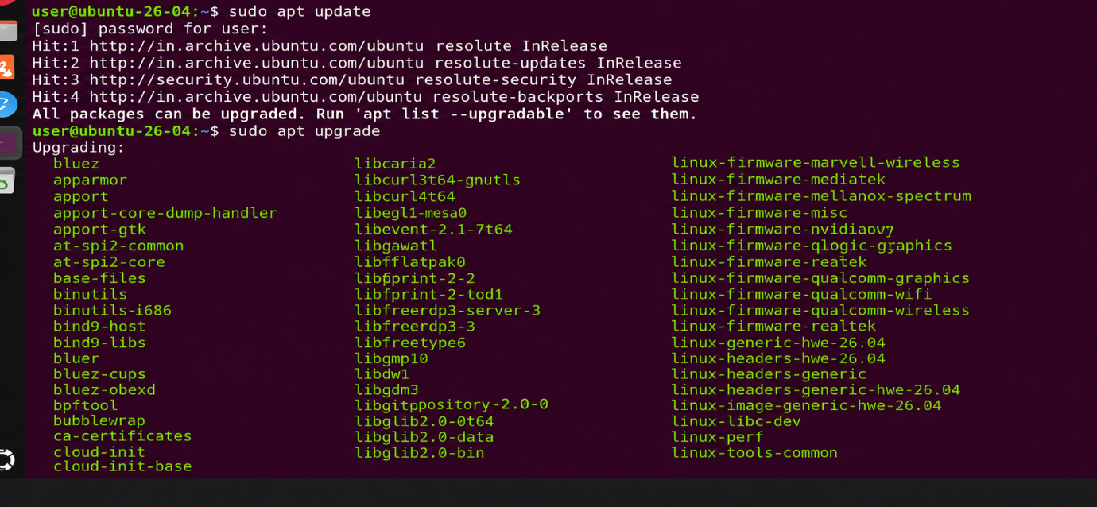
Step 3: Update Ubuntu

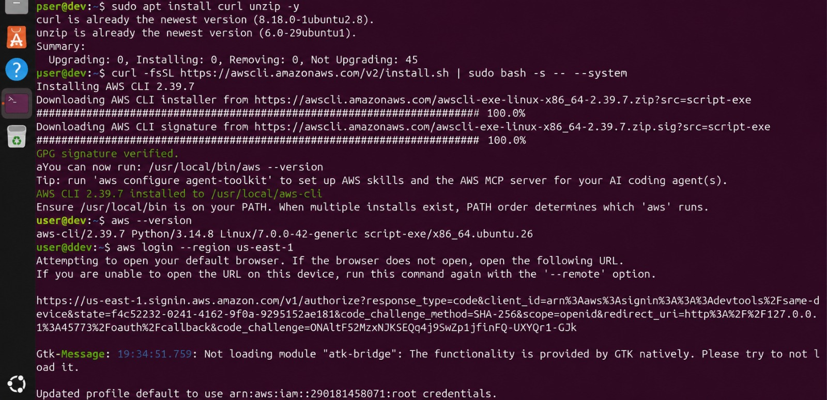
Step 4: Install Basic Utilities

Task 2A: Introduction to AWS Management Console
Step 1: Access AWS Management Console
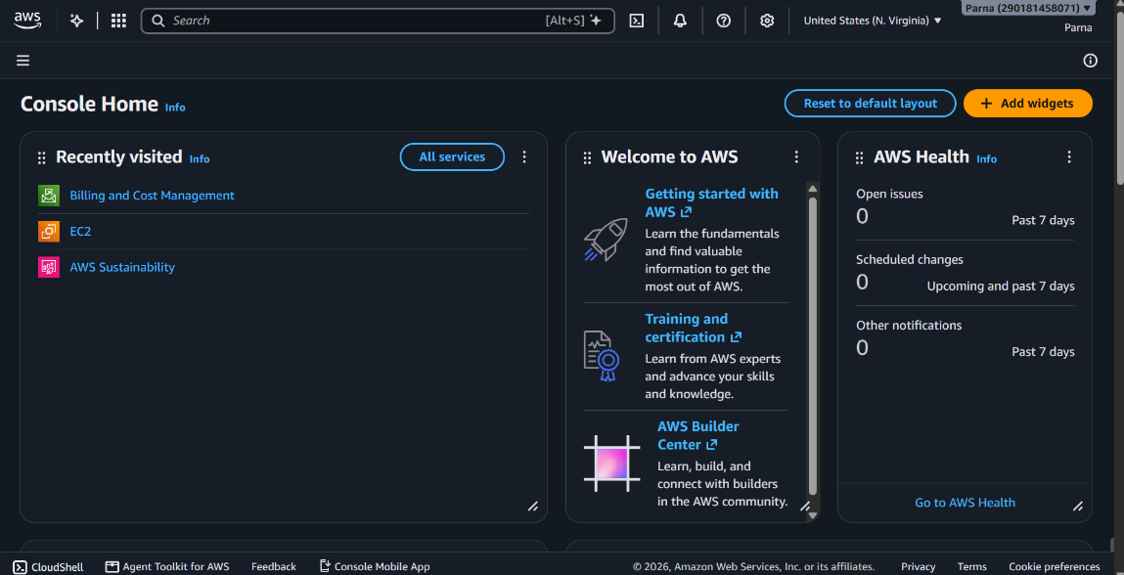

Task 2B: Implementation of Cloud Storage Using Amazon S3
Step 1: Open Amazon S3
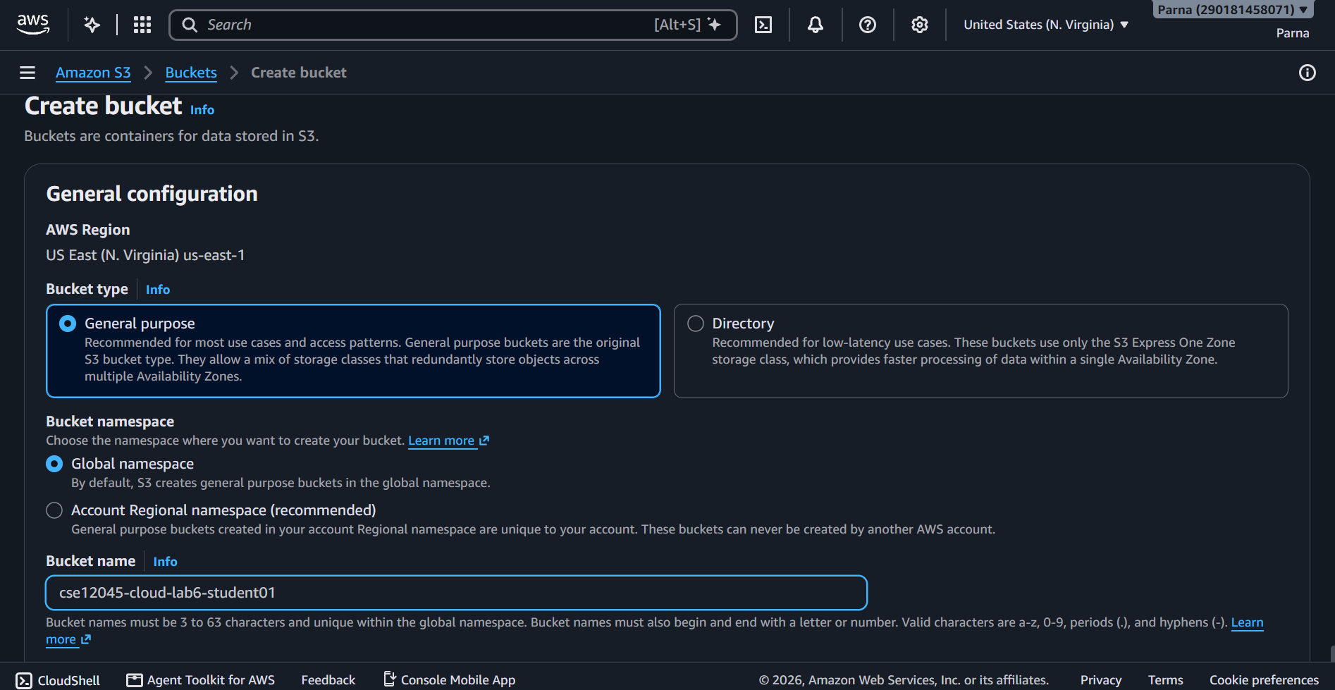

Step 2: Create an S3 Bucket
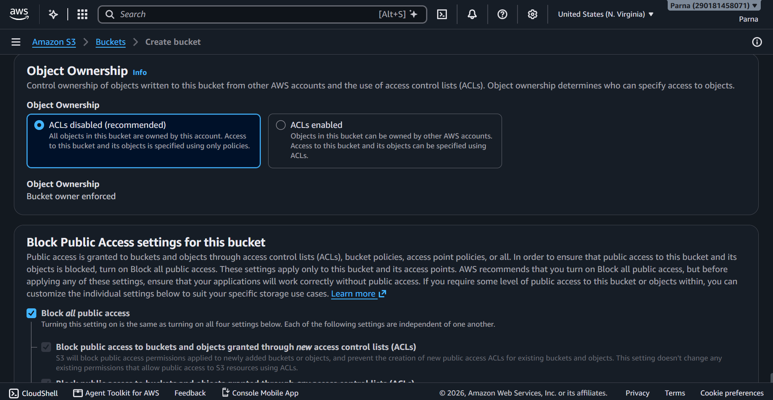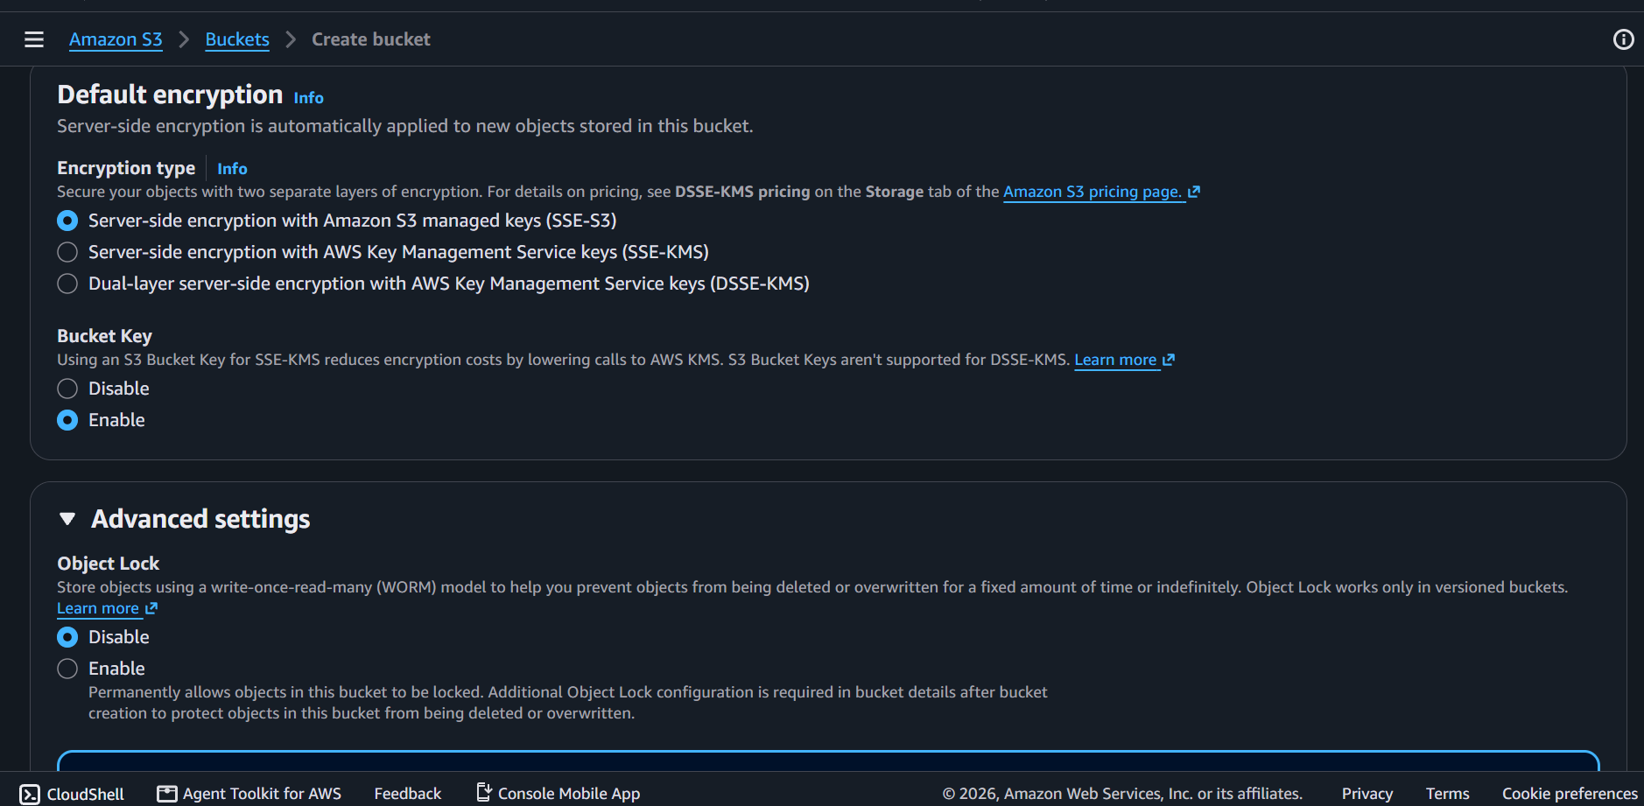
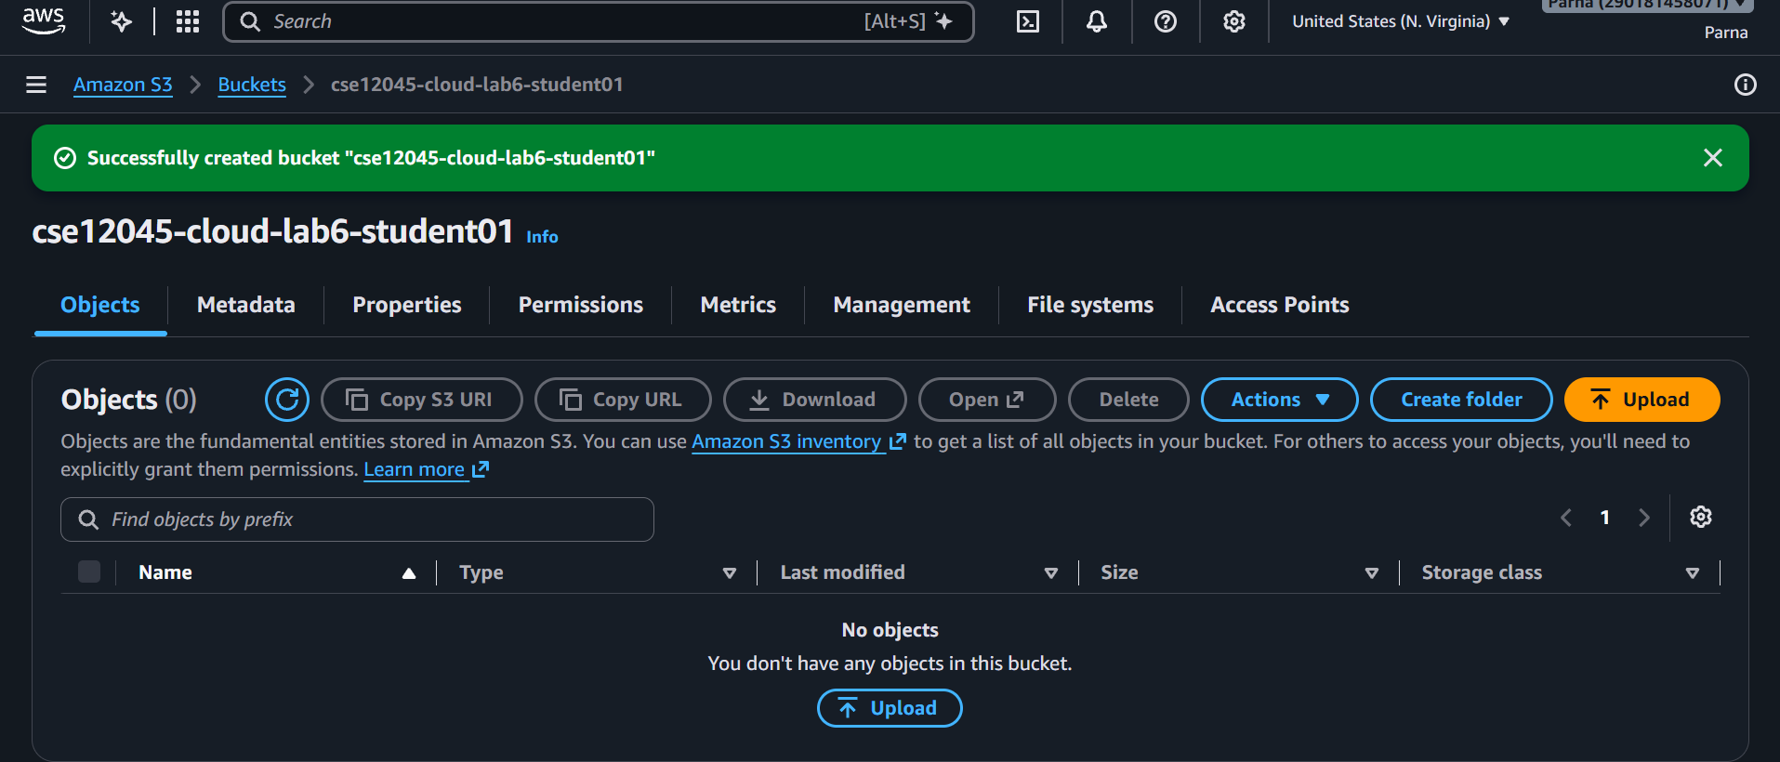

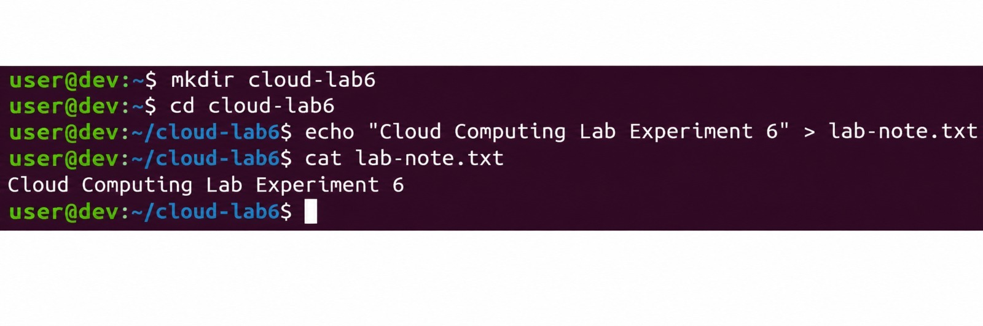
Step 3: Create a Sample File in Ubuntu
Step 4: Upload a File to S3
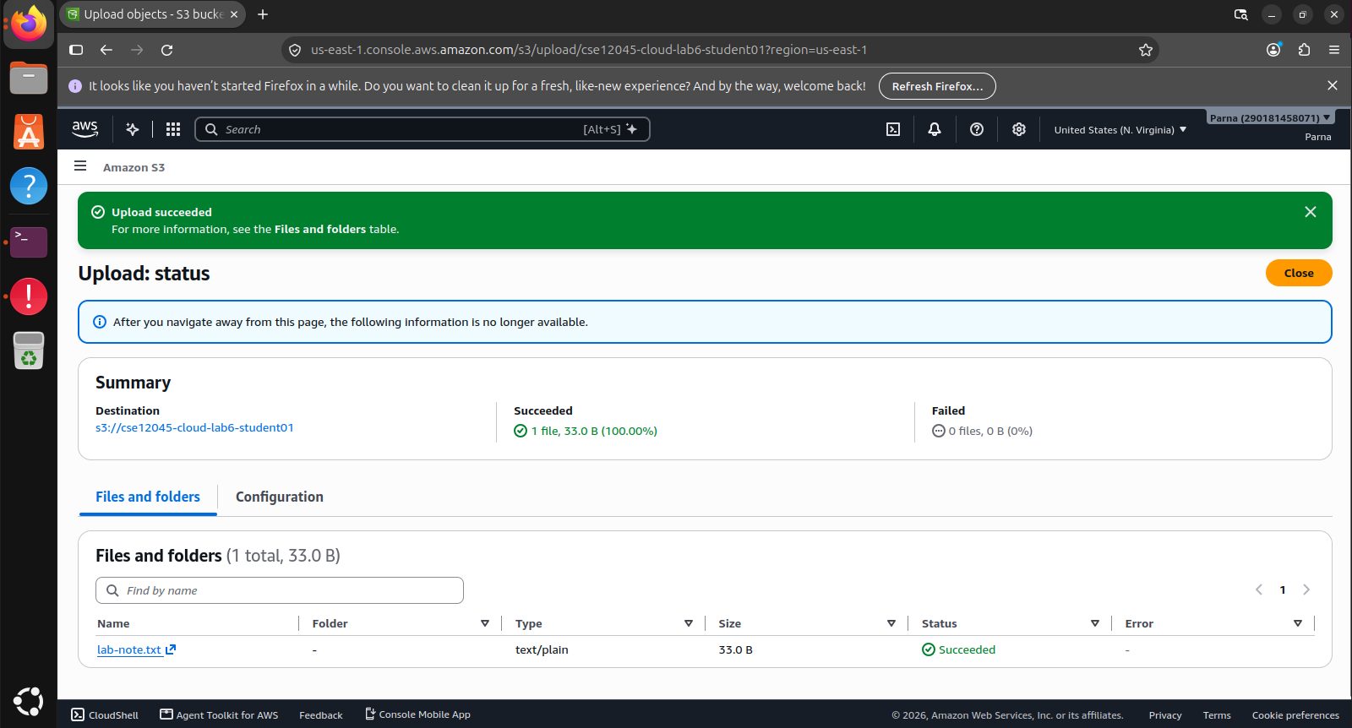
Step 5: Download the File
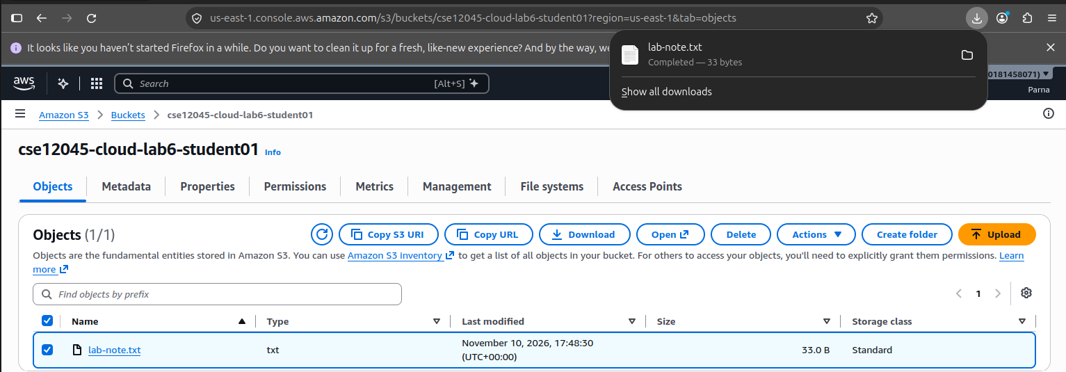
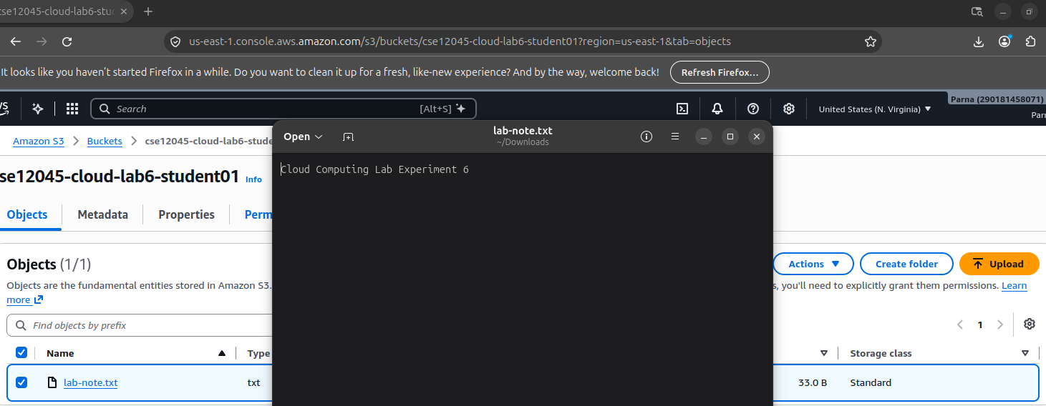
Step 6: Delete the Test Object and Bucket

Task 3A: Identity and Access Management Using AWS IAM
Step 1: Open IAM
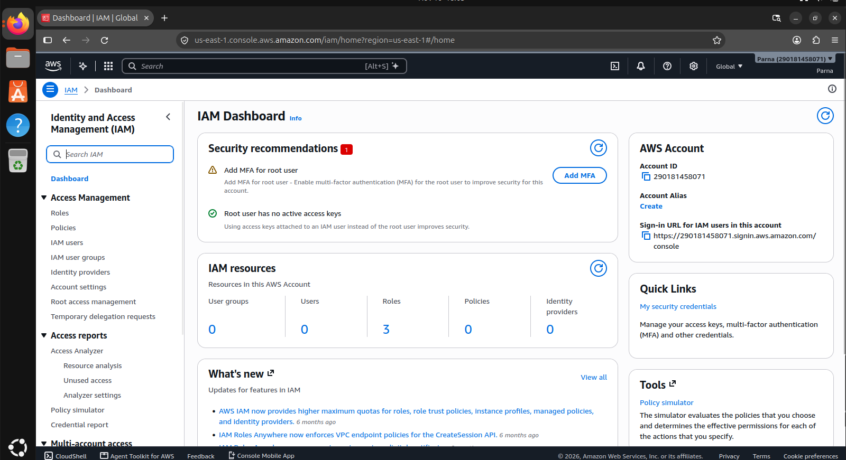
Explore the Users, Groups, Roles and Policies sections.
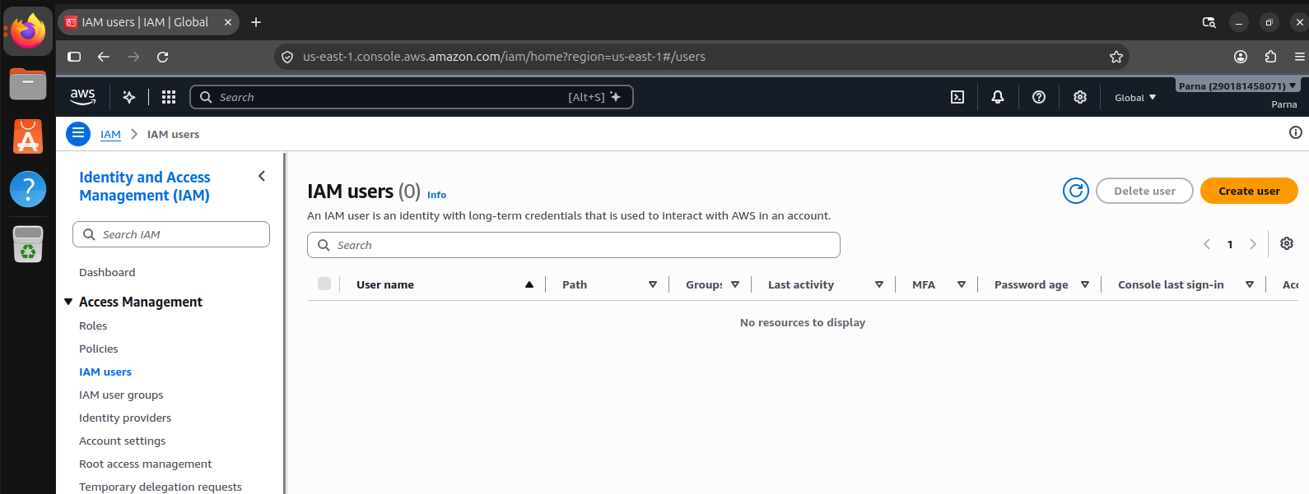
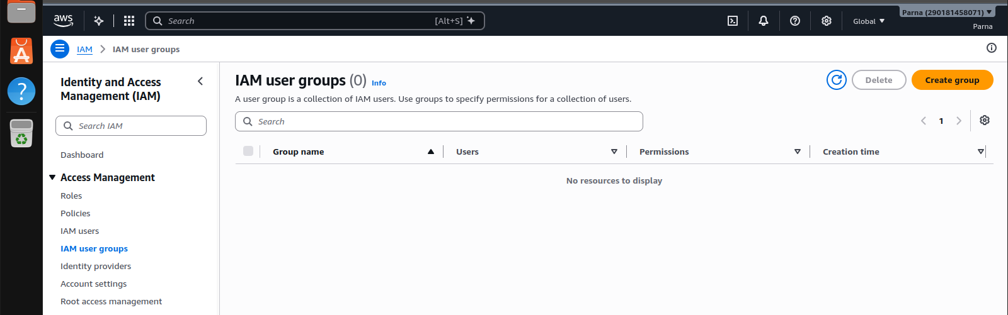
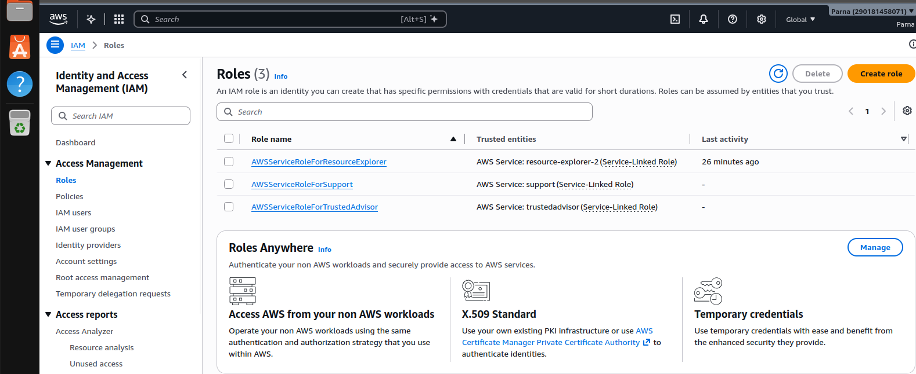

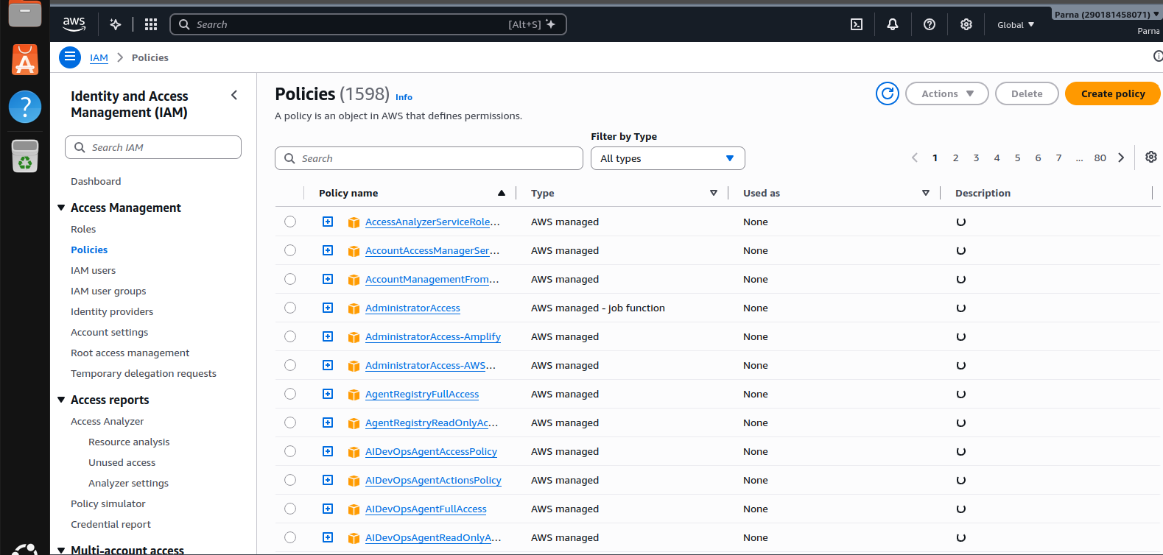

Task 3B: Virtual Machine Provisioning Using Amazon EC2
Step 1: Open EC2
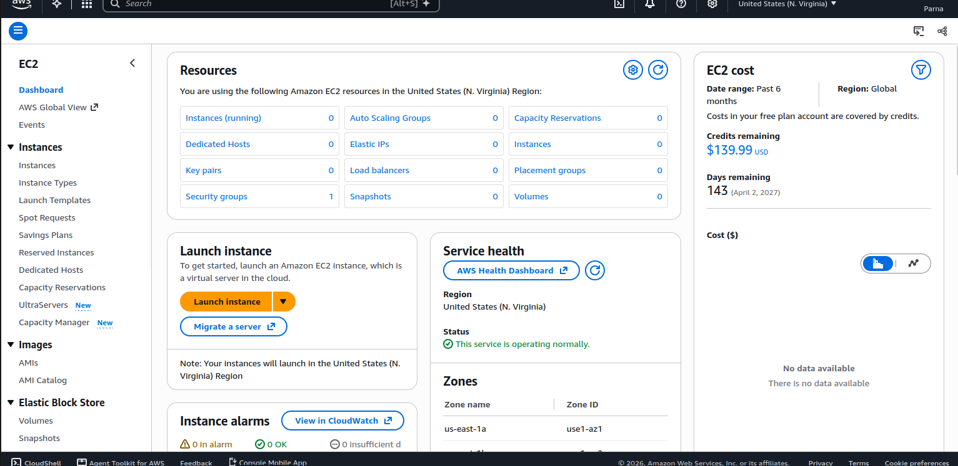
Step 2: Explore the Instance Launch Process
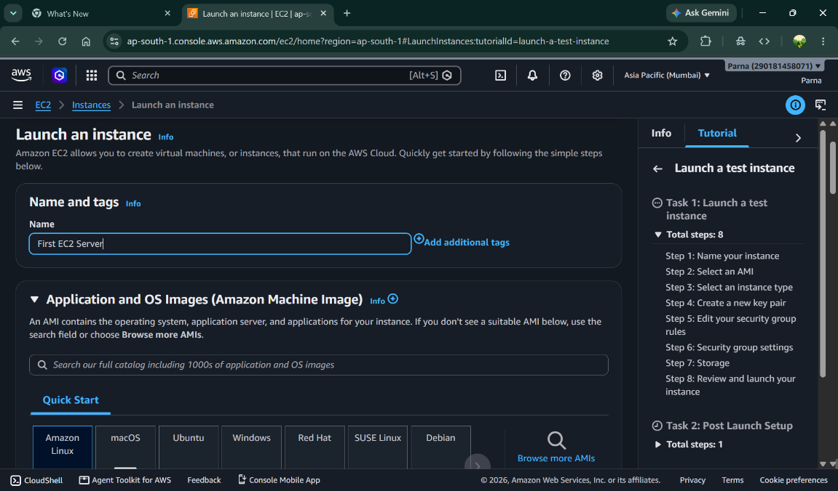
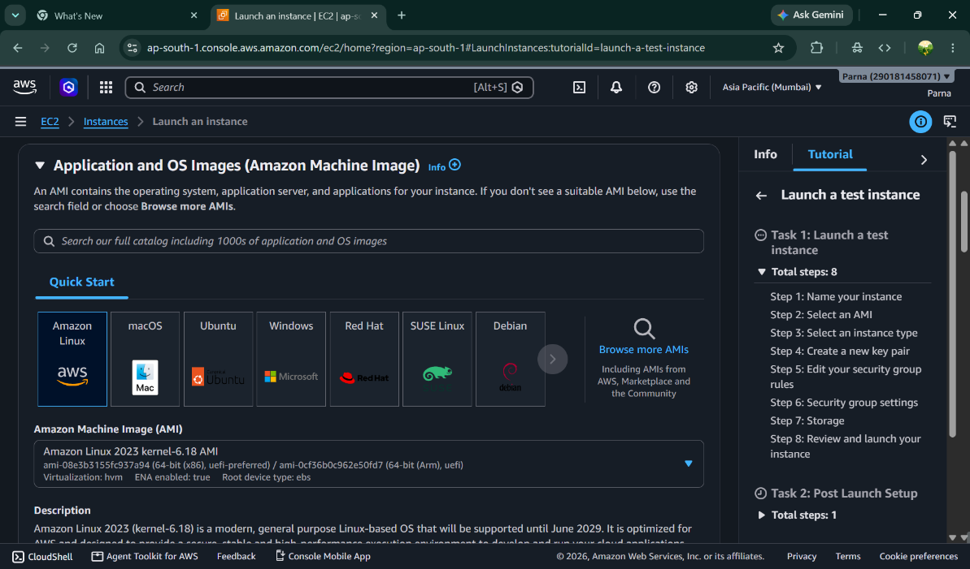
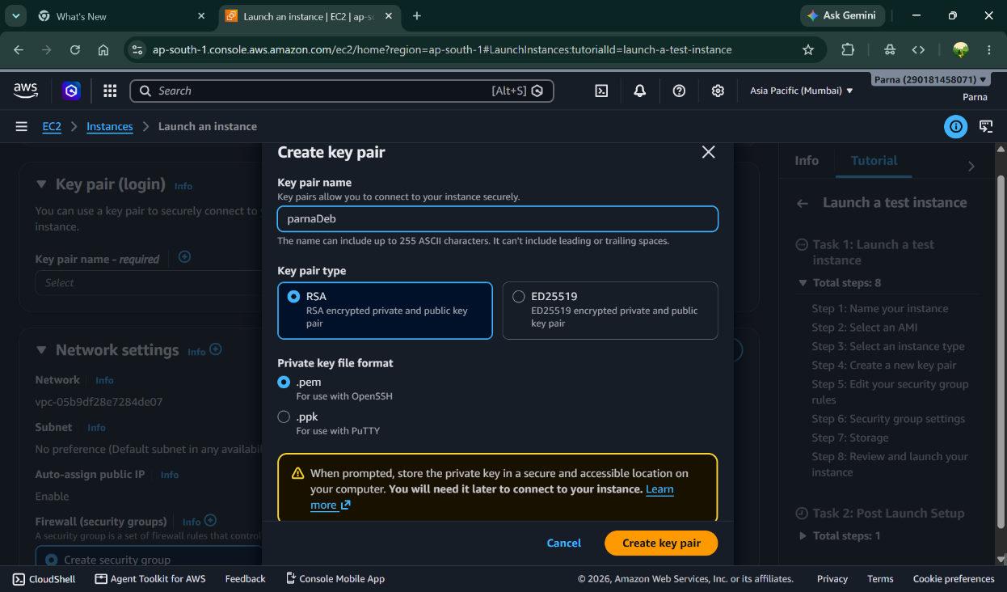
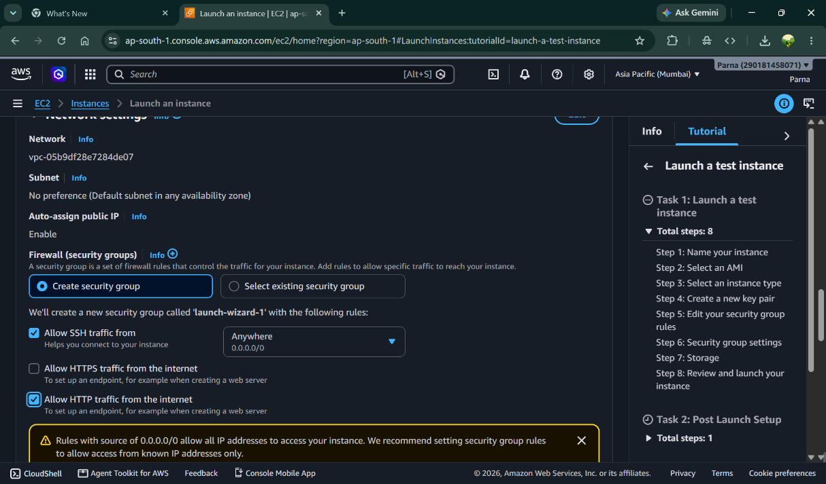
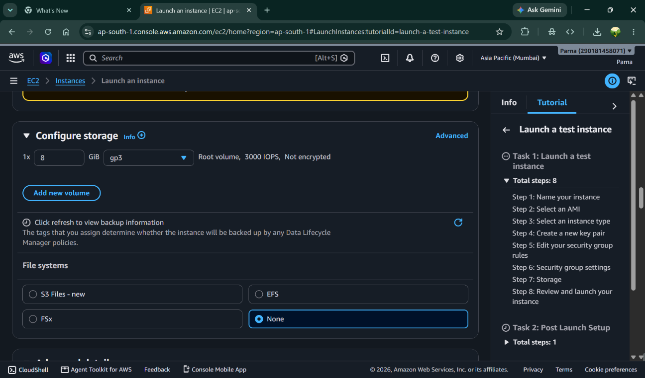

Optional Practical Activity: Launch an EC2 Instance
- Give Instance name

- Select OS Image- Amazon Linux

- Create Key Pair
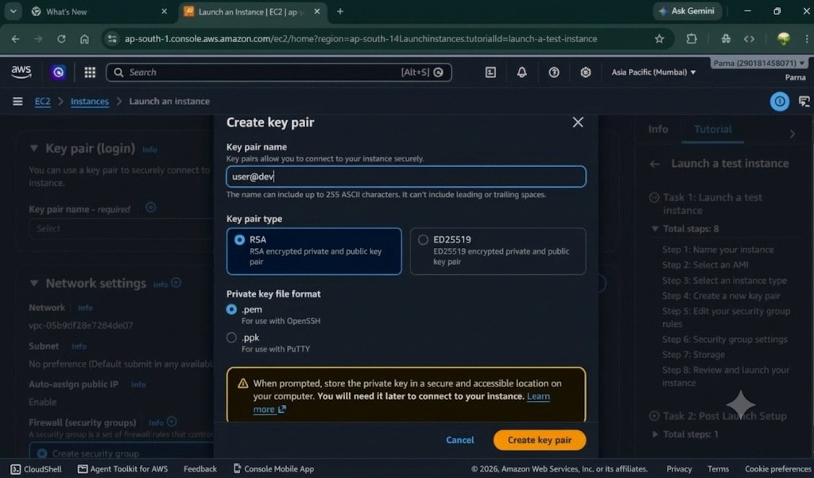

- Setup Network Setting

- Configure Storage

- Advance Setup- Add html script that will run on server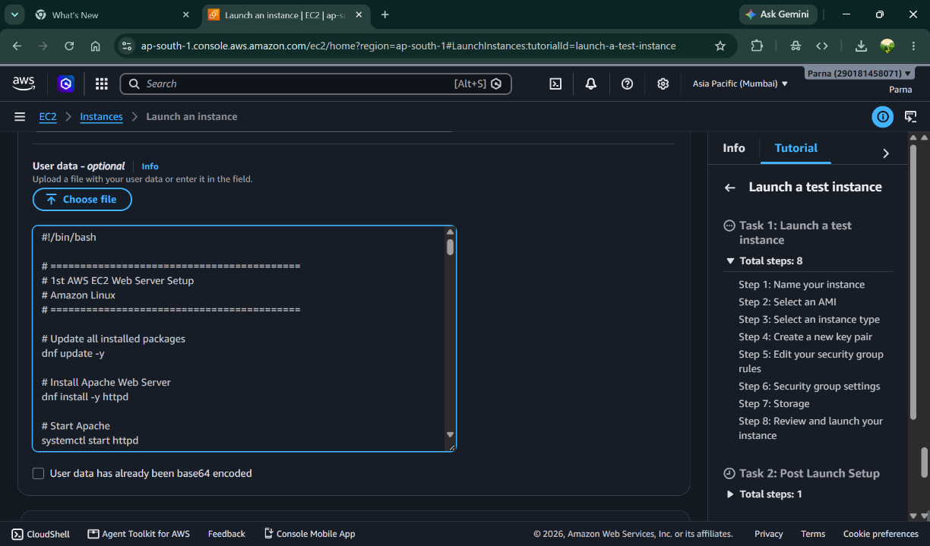

- Launch the instance
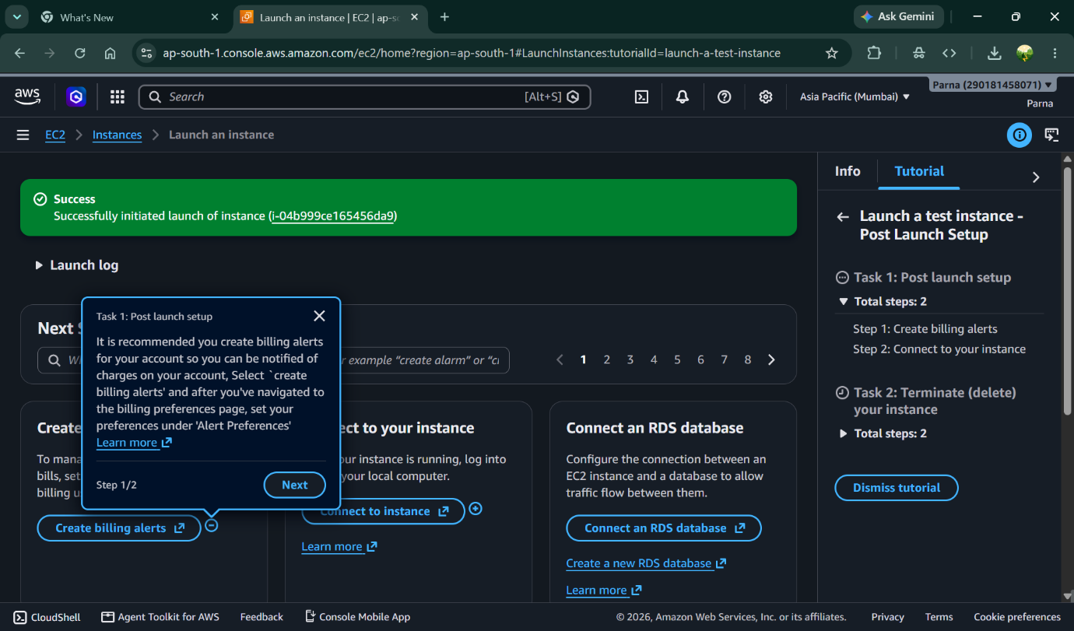

- Instances Running
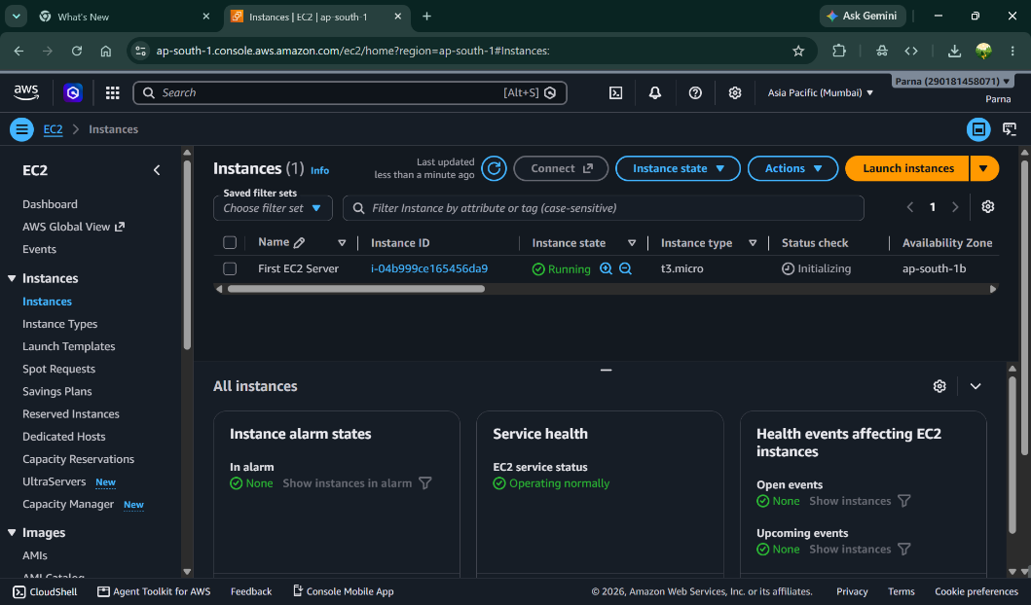
- Instance Detail
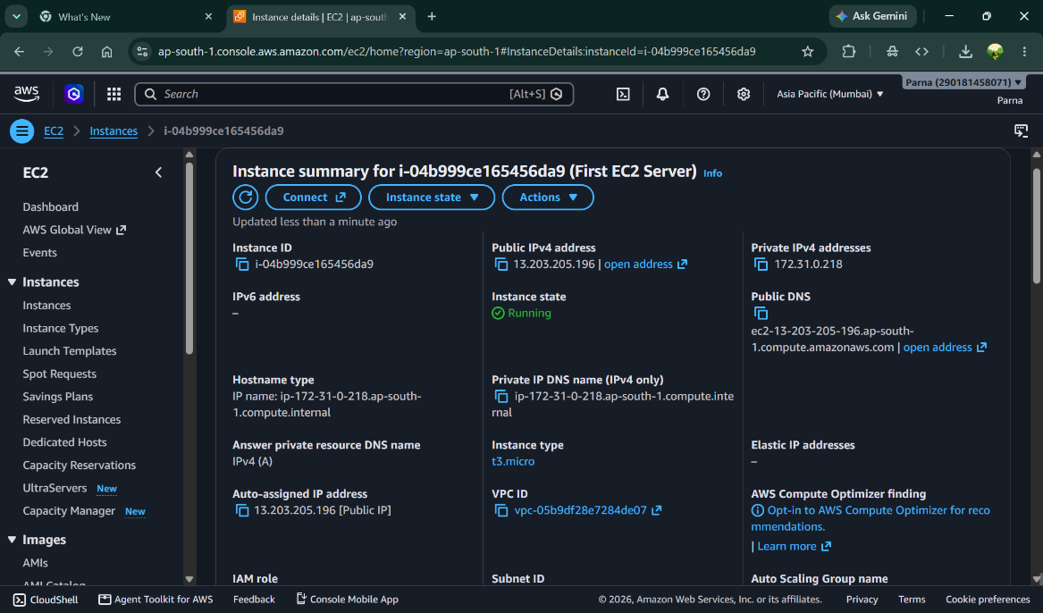

- Termination of Instance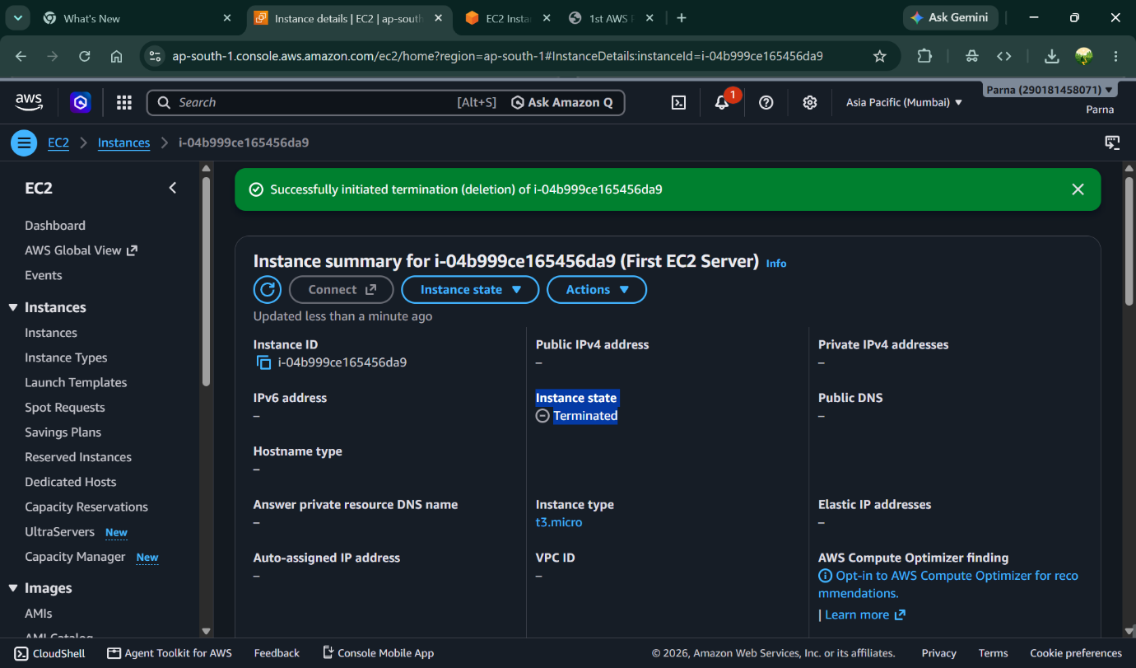

Task 4A: Virtual Networking Using Amazon VPC
Step 1: Open Amazon VPC
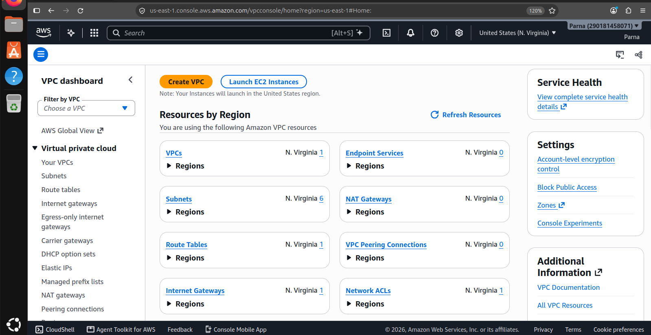
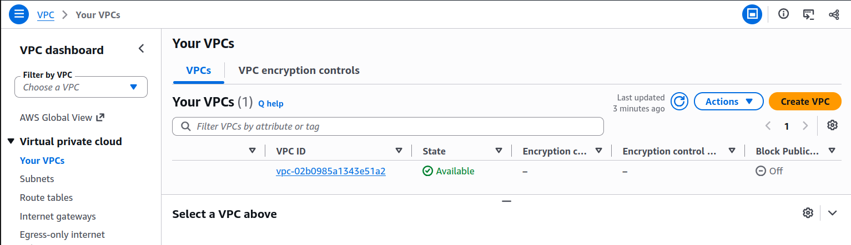
Step 2: Explore VPC Components
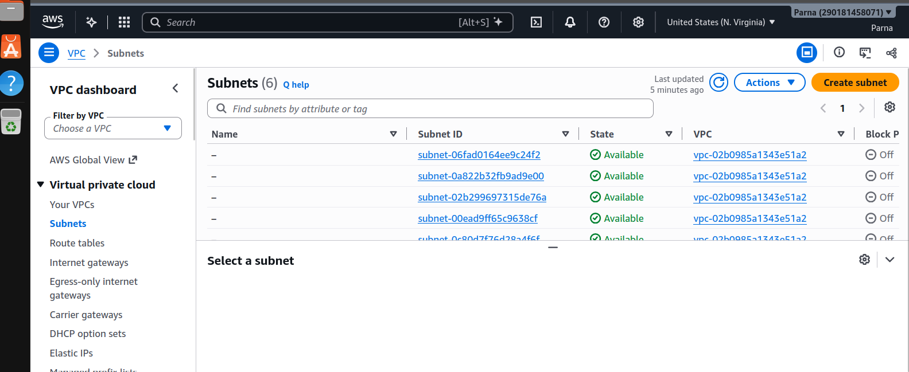
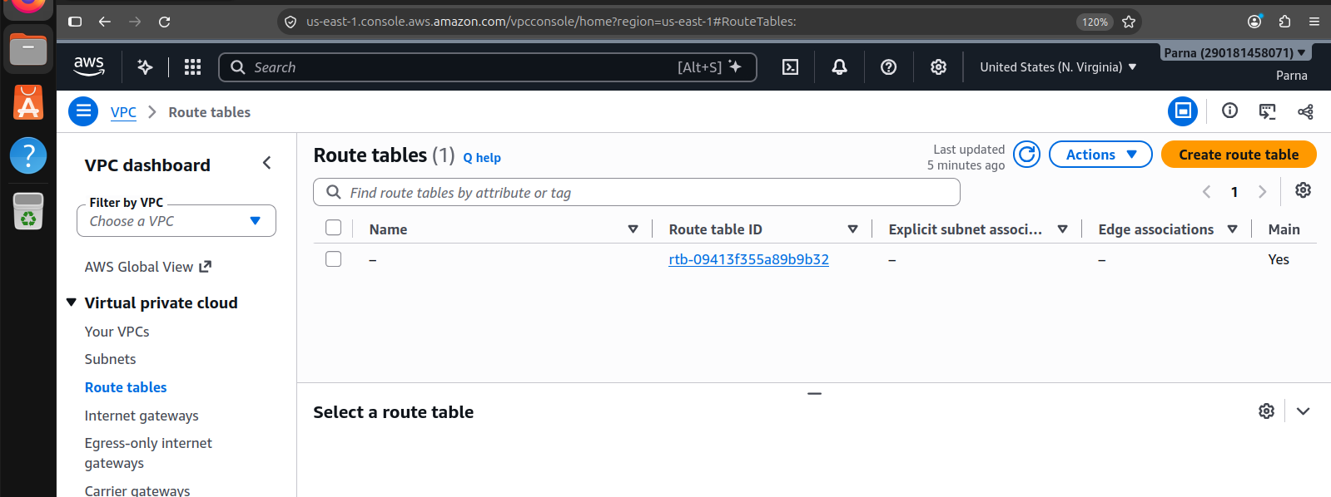
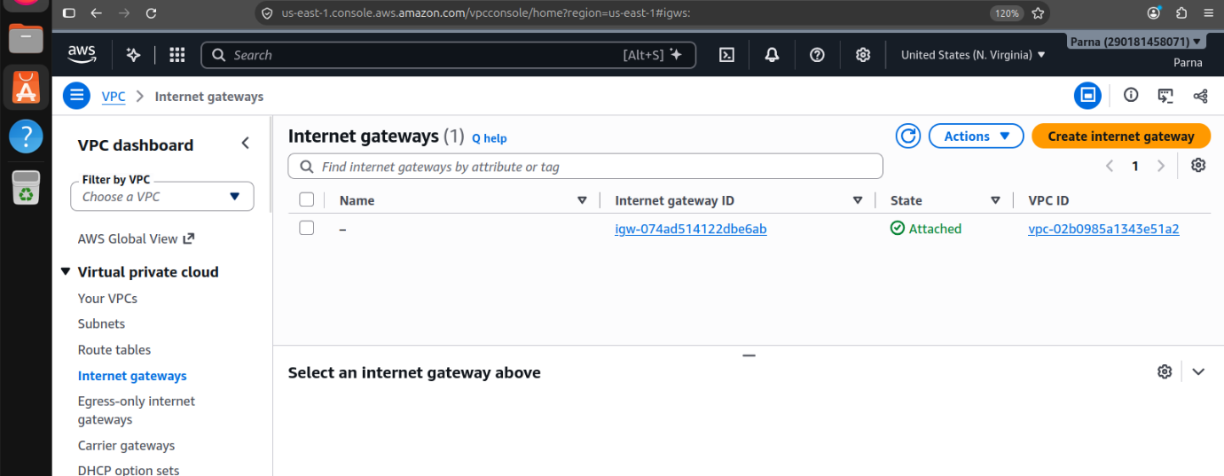
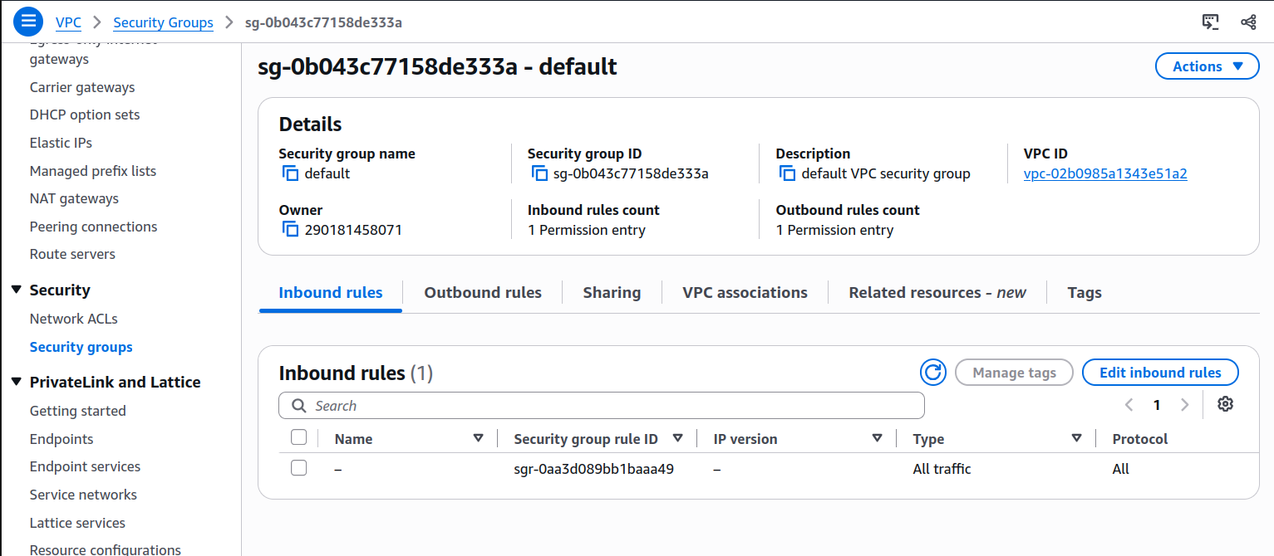
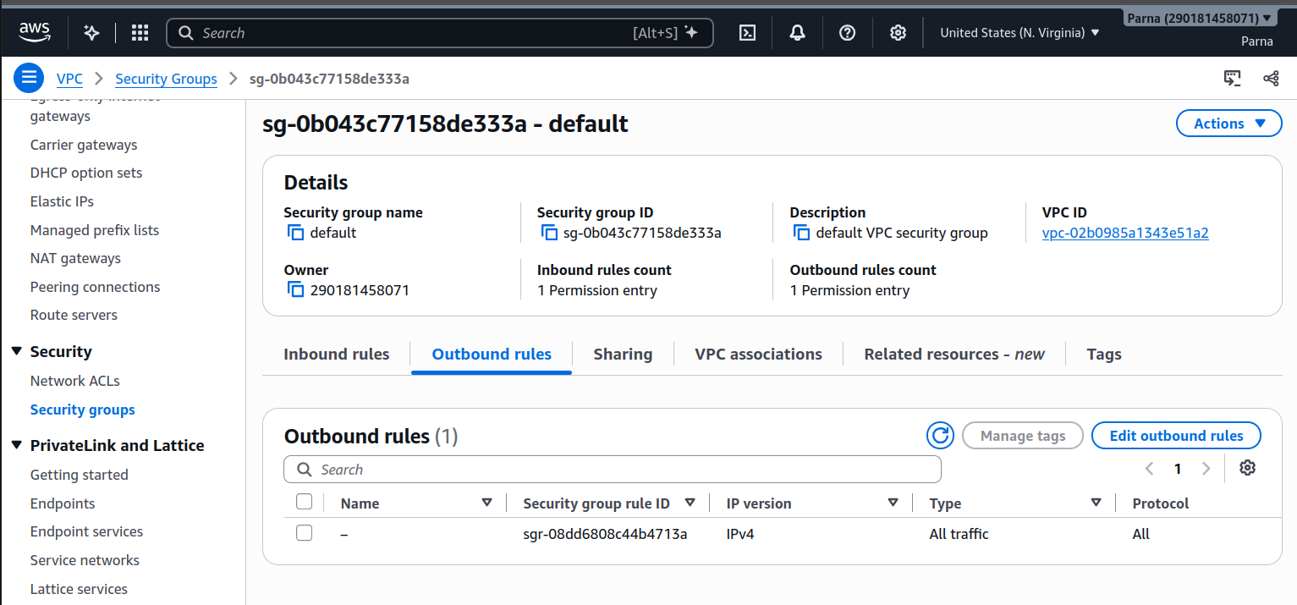

Task 3D: Cloud Monitoring Using Amazon CloudWatch

Step 1: Open CloudWatch
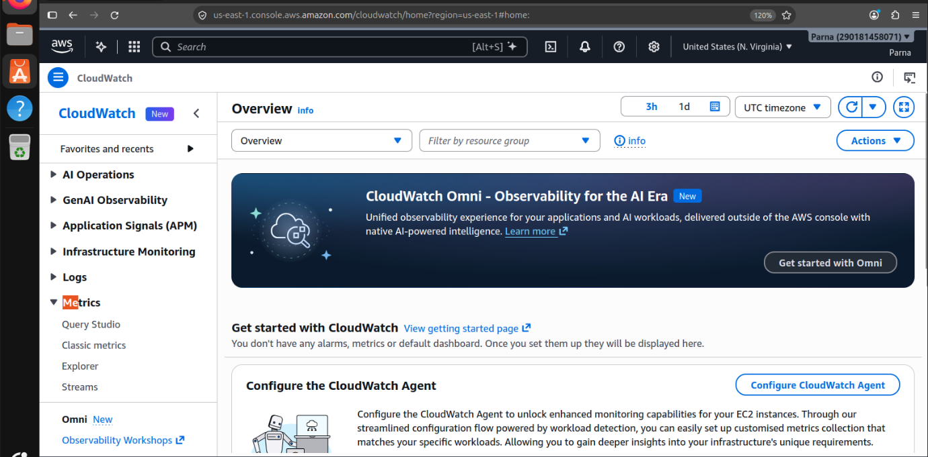
Step 2: Explore Metrics
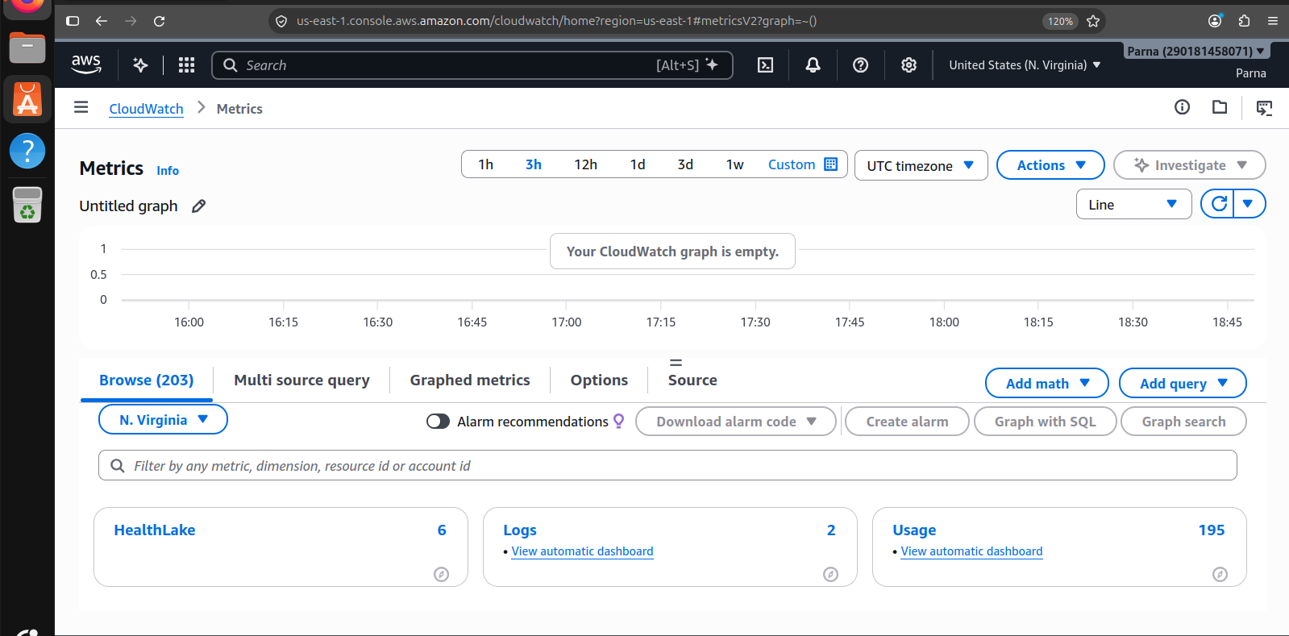

Step 3: Explore CloudWatch Alarms
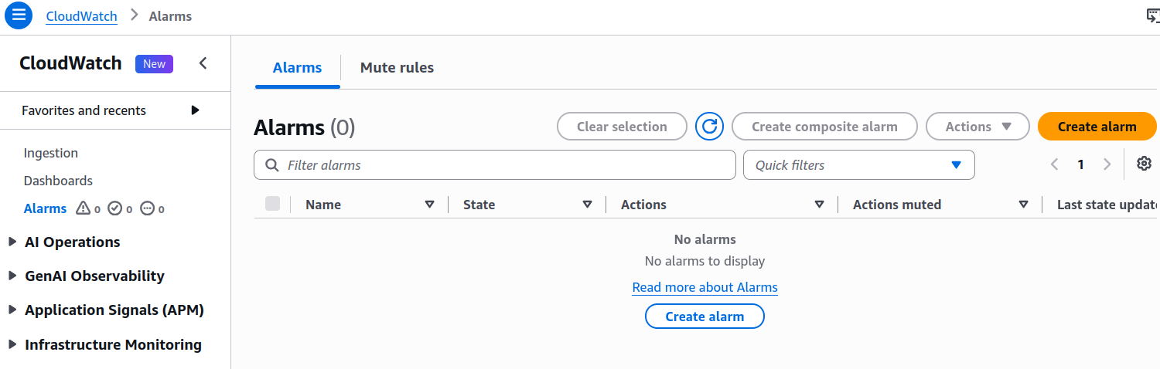
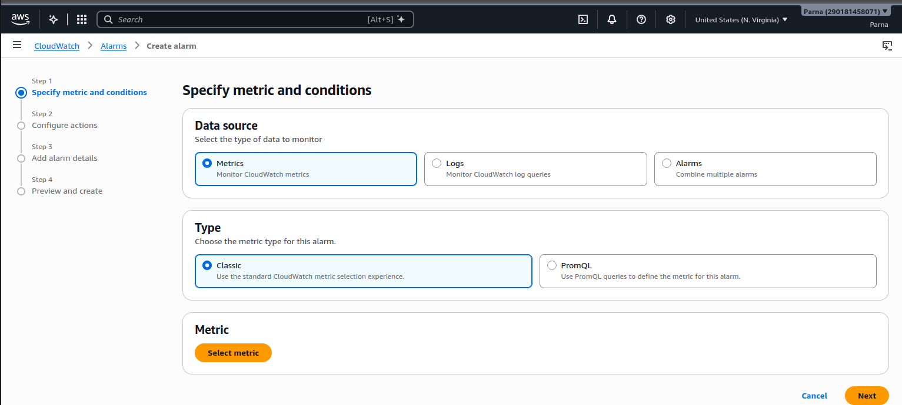
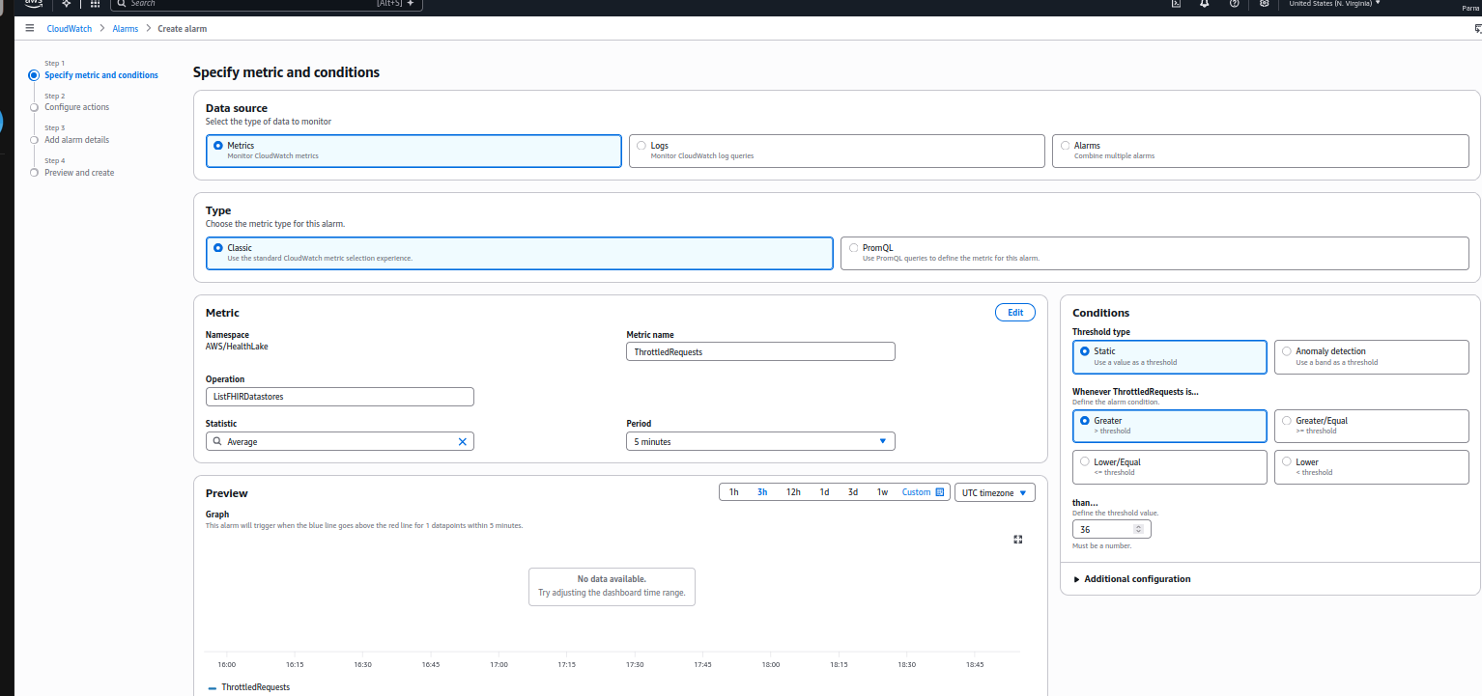

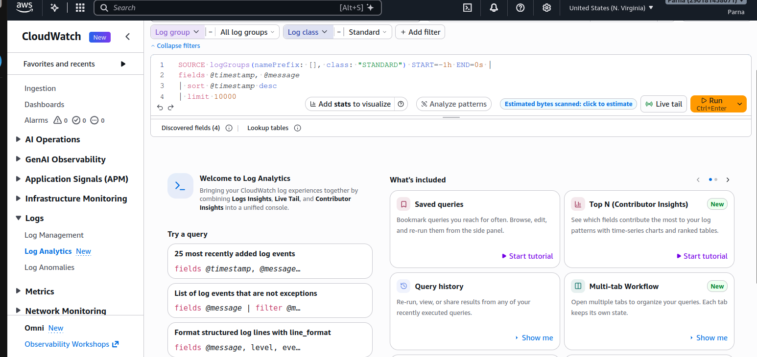

Task 4B: Basic AWS Operations Using AWS CLI
Step 1: Open AWS CloudShell
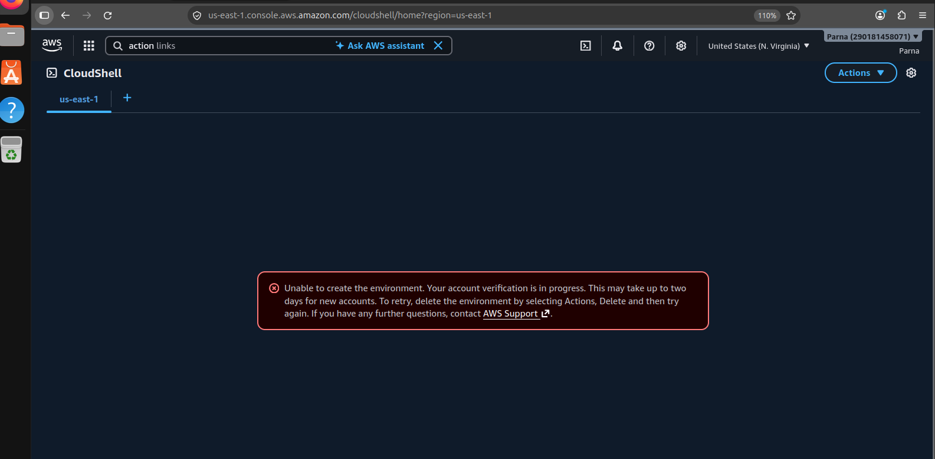
Step 2: Verify AWS CLI Installation
Step 3: Verify AWS Account Identity
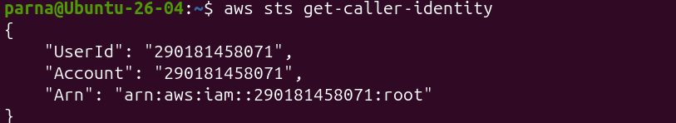
Step 4: List Available S3 Buckets
Step 5: Create a Local File
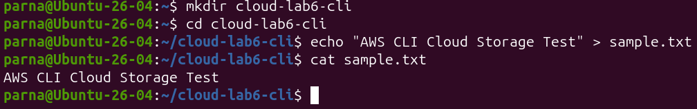

Step 6: Upload the File to S3

Step 7: List Objects in the Bucket

Step 8: Download the File

Step 9: Verify the Downloaded File

